

DEDAN KIMATHI UNIVERSITY OF TECHNOLOGY
SCHOOL OF COMPUTER SCIENCE AND INFORMATION TECHNOLOGY
PROJECT DOCUMENTATION FOR FINAL YEAR IN:
BACHELOR OF SCIENCE IN INFORMATION TECHNOLOGY
BY:
NAME: JOSEPH KINYUA
REGISTRATION NUMBER: C025-01-0632/2020
PROJECT TITLE
HOTSPOT BILLING SYSTEM FOR INTERNET DISTRIBUTORS
SUPERVISOR
ELIZABETH MUTUA
This project progress has been submitted to the Department of Information of Technology in the School of Computer Science and Information Technology in partial fulfilment of the requirements for the award of degree in Bachelor of Science in Information Technology at the Dedan Kimathi University of Technology.

SEPTEMBER 2024

DECLARATION
This project progress is my original work and has not been presented for a degree in any other University.
Name: Joseph Kinyua Date:
Signature:

This project progress has been submitted for examination with my approval as University Supervisor
Name: Elizabeth Mutua Date:
Signature:

ABSTRACT
The increasing demand for reliable and secure internet connectivity, especially in businesses, public spaces, and venues, has created a need for efficient management of Wi-Fi access. However, many providers face challenges in fairly billing users, controlling network usage, and monetizing the service effectively. This project proposes a comprehensive and user-friendly hotspot billing system to solve these issues by streamlining the process of billing and authentication for Wi-Fi users.
The system has two modules: the customer and the admin module. The customer module handles customer-related services like authentication, billing, provisioning, and self-care. The admin module handles services like user management, subscription plan management, and monitoring. The key features of the hotspot system include user registration, billing, payment integration, and usage monitoring and analytics. The proposed system can regulate users' consumption of internet resources depending on the provider's package offering. Thus ensuring that customers are adequately and fairly billed for their Wi-Fi usage.
To summarize, incorporating a strong hotspot billing system into operations can simplify network administration, improve customer satisfaction, and optimize revenue generation for hotspot proprietors and operators. Utilizing its distinctive attributes and customized deployment strategy, this system solution offers a valuable chance to efficiently monetize Wi-Fi networks while ensuring dependable and safe internet connectivity for users.

Table of Contents
CHAPTER ONE: INTRODUCTION 4
1.1 Background 4
1.2 Problem statement 4
1.3 General objective 5
1.3.1 Specific objectives 5
1.4 Research questions 5
1.5 Scope 6
CHAPTER TWO: LITERATURE REVIEW 7
2.1 Introduction 7
2.2 Case studies 7
2.2.1 Case 1: Internet authentication and billing system using MikroTik router operating system 7
2.2.2 Casa 2: Wi-Fi Login Authentications System Using MikroTik 8
2.2.3 Case 3: Mawingu Wi-Fi 8
2.3 Summary 9
2.4 Research Gap 10
CHAPTER THREE: METHODOLOGY 11
3.1 Introduction 11
3.2 Data collection 11
3.2.1 Questionnaires 11
3.3 System Design Methodology 12
CHAPTER FOUR: ANALYSIS AND DESIGN 14
4.1 Introduction 14
4.1.1 Statement of scope 14
4.1.2 Constraints on system Design 14
4.2 Requirements Analysis 15
4.2.1 Functional Requirements 15
4.2.2 Non-functional Requirements 15
4.3 Data analysis 15
4.4 System Analysis 16
4.4.1 Use Case analysis 16
CHAPTER 5: SYSTEM TESTING AND IMPLEMENTATION 21
5.1 Introduction 21
5.2 Testing 21
5.2.1 Unit Testing 21
5.2.2 Integration Testing 25
5.2.3 Implementation 25
CHAPTER 6: CONCLUSION AND RECOMMENDATION 26
6.1 Conclusion 26
6.2 Limitations 26
6.3 Recommendations 26
References 28
APPENDIX A: Budget. 29
APPENDIX B: Project schedule. 30

list of figures
Figure 4.1: Use case Diagram 16
Figure 4.2: Entity Relationship Diagram 17
Figure 4.3: class diagram 18
Figure 4.4: sequence diagram 19
Figure 4.5: flow chart 20
Figure 5.1: Dashboard 21
Figure 5.2: user registration 22
Figure 5.3: Internet usage reporting 23
Figure 5.4: Bandwdth Calculator 24

CHAPTER ONE: INTRODUCTION

Background
Internet access has gradually become a decisive element that significantly affects consumers' choices, and therefore, providing Wi-Fi services has become a strategic advantage for various businesses. However, managing and monetizing these Wi-Fi services can take time and effort. As the need for internet applications increases, a further wireless security system is required, and the network admin will need help meeting the security design (Soewito & Hirzi, 2014). These challenges justify the introduction of a robust and secure hotspot billing system.
Ensuring fair and controlled usage of the hotspot is a challenge for owners and operators as some users can consume more bandwidth, depriving others of seamless connection. Payment collection is another major challenge in the internet service provision, leading to revenue leakages and delays. The existing systems also lack a monitoring system that gains insight into network usage, peak hours, and performance metrics. Unoptimized bandwidth management can cause security issues for the user and service provider (Rahman & Haviluddin, 2016).
A dedicated hotspot billing system solution is recommended to address these challenges and optimize hotspot management. The proposed system can regulate users' consumption of internet resources depending on the provider's package offering. This can be in capped or uncapped data plans, time-based usage, speed-limited packages, or tiered service levels. Thus ensuring that customers are adequately and fairly billed for their Wi-Fi usage. The system also aims to automate authentication, billing, usage control, and payment collection processes while offering the network admin the rights to manage users (Onno et al., 2012).
The proposed system is designed to provide seamless, scalable, and reliable internet access for users while allowing proprietors to control internet usage and costs. It executes secure authentication processes and integrates with payment systems to enable proprietors to charge users based on their internet consumption.

Problem statement
The demand for seamless internet connectivity is higher than ever, and therefore, hotspot services have become a vital amenity, enabling people to stay connected on the go. This has created the need for a versatile network environment that is designed to accommodate a large number of users. To help network administrators manage such a complex environment requires implementing a convenient system (Kao et al., 2020).
The existing hotspot billing systems may need more capacity to track users' internet utilization accurately, resulting in billing discrepancies and customer dissatisfaction. This results from the lack of a dynamic billing system that accommodates diverse payment options and ensures fair billing plans. According to (Parmanasari et al., 2015), the current bandwidth management is done manually by dividing the system equally in canals. It is not practical since the need of each canal is different. (Parmanasari et al., 2015) It also suggests that automating the bandwidth is possible; however, the bandwidth analysis should be done before automation.
To address these issues, there is a need for a robust hotspot billing system capable of accurately tracking user surf time and bandwidth consumption and correctly billing them. By developing an efficient Hotspot Billing System, businesses can enhance customer satisfaction and optimize their operations, leading to increased revenue and improved reputation.

General objective
To efficiently manage and monetize Wi-Fi services while ensuring a seamless and secure user experience.

Specific objectives
- To register users
- Allocate bandwidth to users
- Predict user bandwidth usage based on historical data usage
- To allow users to make payment
- Generate report on user activity and suggest the best data plan for the user

Research questions
- What are the most effective and user-friendly methods for simplifying the user registration process?
- What adaptive algorithms can be developed to dynamically allocate bandwidth among users in real-time, ensuring fair and efficient distribution based on user demands and network conditions?
- What data analytics techniques can analyze historical data patterns and accurately predict user bandwidth requirements?
- What are the most effective methods to enable users to make secure and easy payments in an online setting?
- What parameters are essential for comprehensive user activity reporting, and how can they be analyzed to provide valuable insights to both users and service providers?

Scope
This hotspot billing system will provide internet providers with user-friendly system that will make it easy for efficient hotspot management. The system will enable bandwidth tracking, user management, notification alerts for available plans, and statistical analysis for usage and economic statistics.
The system will provide features such as billing plans, payment gateway integration, invoicing, usage tracking, bandwidth management, and financial reports to help internet service providers use data collected to make informed decisions on the rate plans to charge customers, cautioning them against losses while providing seamless services. The hotspot billing system eliminates the problem of calculating the profit or loss. The system will provide data to help internet providers know the amount of internet consumed against the payment.

CHAPTER TWO: LITERATURE REVIEW

Introduction
This review examines the existing knowledge on Hotspot Billing Systems, a modern technology in internet service provision. These systems present a crucial framework by which service providers can manage, measure, and monetize internet usage across different platforms, offering a critical underpinning to robust revenue management. This literature review delves into the intricate world of Hotspot Billing Systems, exploring the vast array of research, technologies, and methodologies that have shaped their evolution. By examining existing literature, this review aims to unravel the diverse system architectures, functionalities, and types of pricing models. The landscape of Hotspot Billing Systems will be surveyed, and the incorporation of safe payment channels will also be covered, along with the numerous authentication techniques used, the adaptability of billing plans, and the complexity of usage monitoring. This review will also examine how Hotspot Billing Systems affect enterprises, end users, and the broader socioeconomic environment. This review attempts to find trends, gaps, and new technologies in the field of Hotspot Billing Systems through a thorough investigation of the available literature. The assessment will advance awareness of the difficulties and opportunities faced by companies and service providers in the dynamic world of public internet access by synthesizing this wealth of knowledge.

Case studies

Case 1: Internet authentication and billing system using MikroTik router operating system
The Federal University of Technology, Minna, recognized the need to provide reliable internet access to its students, staff, and faculty. In response, they implemented an Internet Authentication and Billing Hotspot System. This system not only ensures reliable internet connectivity but also offers free access to the department's mini portal website and serves as a virtual notice board for disseminating vital information across the campus using wireless Wi-Fi technology. The implementation began with a thorough understanding of the networking infrastructure required for the hotspot system. The researchers studied the MikroTik hotspot server, which was deemed suitable for the university's needs. The hotspot server was designed with a single wireless interface strategically placed within the department to ensure maximum student coverage. The system used radius server service to enhance the management and accounting of the hotspot wireless server. This radius server service allowed for user account and session management, ensuring secure authentication and billing for internet usage. Based on the execution of this project, the following recommendations are made: Incorporate additional stages into the antenna design to further boost the coverage on the Federal University of Technology, Minna campus. Implement and activate a radius server service to improve the management and accounting of the hotspot wireless server (Saliu, 2013).
In conclusion, the successful implementation of the Internet Authentication and Billing Hotspot System at the Federal University of Technology, Minna, has significantly improved internet connectivity on campus. This case study highlights the importance of wireless network development in national building efforts and showcases the benefits of providing reliable internet access to students and faculty. By incorporating additional stages and implementing a radius server service, the university can continue to enhance the performance and coverage of its hotspot system.

Casa 2: Wi-Fi Login Authentications System Using MikroTik
In this case study, we will analyze the development of a secure Wi-Fi login portal using the MikroTik HAP Lite RB941 2nD router. This project aims to create a user-friendly and efficient login system that ensures secure access to the Wi-Fi network while offering convenient onboarding for users. The system utilizes the features of MikroTik HAP lite RB941-2nd router, Winbox system, and Visual Studio to create a login portal for users to access the WIFI network. The system also provides an analysis of internet usage against time. The system reports the amount of data (megabytes) used on a network over time (hours), providing valuable insights into usage trends and anomalies. This information can be helpful for network administrators in optimizing network performance and identifying and troubleshooting usage-related issues. The project has a keep alive feature that disconnects the user if there is no traffic for a specific period. The system provides both security and the ability for network administrators to monitor and control network usage (Khairuddin1 & Bahari, 2023).

Case 3: Mawingu Wi-Fi
The Mawingu hotspot Manager Solution is a Captive Wi-Fi Portal Solution or "Subscription Network" that redirects users of a wireless network to an authentication page before they are granted access to the internet and is commonly used in coffee shops, internet cafes, hotels, airports, and other public locations. Mawingu Networks is a noteworthy example of a company utilizing innovative technological solutions to overcome infrastructural challenges and provide affordable internet access to underserved areas. Based in Kenya, Mawingu Networks is focused explicitly on catering to the country's rural areas. It was established in 2014 as a non-profit with the initial goal of supplying energy to low-income rural communities, but it swiftly developed into a significant Internet Service Provider (ISP). Mawingu shifted its attention to tackling these issues when it became clear that rural populations needed reliable internet connectivity more than ever and faced obstacles. Mawingu Networks and ARK developed a re-branding and positioning strategy in 2022 to increase the ISP's visibility in rural Africa. The goal was to increase brand recognition, simplify the product portfolio, and improve internal focus and clarity. Mawingu system outdoes all the other system because it offers multiple devices per subscription. The Mawingu Captive Portal Wi-Fi Solution allows connected clients to extend and share internet access to all or multiple devices under one subscription (Mawingu, 2023).
In conclusion, the implemented solution provided a user-friendly login page, allowing users to connect and authenticate smoothly. The project's objectives of strengthening network security and simplifying user onboarding were achieved. The system's performance and functionality were evaluated, showcasing its effectiveness in providing secure Wi-Fi access. Future enhancements can be made to further improve the system, such as incorporating additional security measures and expanding the capabilities of the login portal. The case study highlights the importance of leveraging suitable hardware and system tools to create robust and user-friendly solutions in the field of network security and Wi-Fi access management

Summary
The use of MikroTik router systems for internet authentication and invoicing is highlighted by two case studies. In the first instance, a hotspot system was installed, providing dependable internet, free access to department portals, and serving as an electronic notice board. The system used a radius server for safe authentication and payment. The suggestions included turning on a radius server service and improving coverage through antenna design.
In the second instance, MikroTik hardware and system tools created a secure Wi-Fi login gateway. The project is intended to improve network security and streamline user onboarding. It had an easy-to-use login page, an internet usage analysis, and a keep alive mechanism to prevent disconnections while no one was using it. Future developments proposed more security safeguards and portal performance improvements. Both cases underscored the importance of MikroTik technology in providing secure and efficient internet access solutions.
The third instance shows how Mawingu WIFI utilizes its hotspot Manager Solution, a Captive Wi-Fi Portal Solution, in public locations such as coffee shops, hotels, and airports. Originally established to supply energy to rural communities, Mawingu shifted its focus to internet connectivity due to the growing need. The Mawingu Captive Portal Wi-Fi Solution allows connected clients to extend and share internet access to multiple devices under one subscription.

Research Gap
Although hotspot billing systems exist, the integration of an algorithm to track user bandwidth management is an unexploited topic. The lack of management and review of hotspot activities or the absence of a system that monitors the activities in the network is an obstacle to the hotspot security system (Damayanti & Sobri, 2020). This research aims to close this gap by implementing an algorithm to track the internet usage of every device connected to the network. This will enable the internet provider to suggest the best plan for the users based on their internet usage.

CHAPTER THREE: METHODOLOGY

Introduction
Seamless internet connectivity is no longer a luxury but a need in our fast-paced digital society. Public Wi-Fi hotspots have proliferated, providing access to the internet in coffee shops, hotels, airports, and other public areas. Hotspot Billing Systems are sophisticated platforms that manage authentication, billing, and usage monitoring for many users and provide internet access due to the growing demand for dependable connectivity. It takes careful planning to develop an effective and user-friendly Hotspot Billing System. Using this process as a guide, the system is developed to fulfil the needs of both enterprises and users. It includes a methodical strategy that addresses the difficulties specific to Hotspot Billing Systems, flawlessly fusing technology, user experience, and business functions. A Hotspot Billing System is rugged to create. It necessitates tackling complex issues, including secure user authentication, adaptable payment options, real-time usage tracking, and integration with various hardware and system settings. To create a reliable, flexible, and user-centric system, a methodology that navigates these obstacles must be developed. A solid methodology is the cornerstone of an effective system development process. This process ensures that Hotspot Billing Systems are technically solid and closely fit with the unique needs of organizations and end users. It offers a systematic approach, outlining the procedures, equipment, and methods that will be used to successfully conceptualize, design, create, develop, test, and implement the Hotspot Billing System.

Data collection
To understand, analyze, and solve a problem or to make informed judgments, fact-finding is the systematic process of acquiring information, facts, and specifics. The characteristics and the amount of data and information to be collected determine the techniques used.

Questionnaires
This research utilizes questionnaires as the primary method of data collection due to the following advantages: cost-effective: The cost of collecting data can be massive, especially if one does not have external funding, but with questionnaires and surveys, one can collect massive data while incurring low costs, questionnaires are versatile allowing the researcher to collect various types of data, including demographic information, opinions, preferences and behaviour patterns. The questionnaires will be designed and distributed among the targeted group to facilitate the process of data collection.

System Design Methodology
The system development methodology for the project is discussed in this section. It also goes through the rationale for the technique adopted. If a proper technique is utilized, an exemplary system will be built. As a result, the benefits of utilizing a based model as a development approach will be addressed. Furthermore, methodology aids in the estimation of the time and cost required to construct a system. In this chapter, the rationale of hardware and system is discussed. The methodology of the based model will be presented in detail in this chapter.
Agile methodology involves a series of phases. The project is first developed and released to the customer for feedback. The process is then iterated a few times until it meets all the customer's requirements. Agile is a conceptual framework for system engineering that begins with a starting planning phase and follows the road toward the deployment phase with iterative and incremental interactions throughout the project's life cycle. The initial goal of the agile method is to reduce the overhead in the system development process with the ability to adapt to changes without risking the process or excessive rework (Al-Saqqa, 2020). Sprints and feedback from the user facilitate a better, more efficient, and flexible system that can cope with changes in the user's requirements. During the continuous and iterative testing stages, bugs and errors can be debugged and corrected, hence an effective, high-quality product.
Moreover, agile has a six-phase life cycle. They include;
- Concept. The scope of the project is determined. The requirements are discussed and documented. The time and cost of the project are determined.
- Inception. Finding the necessary tools and resources. The stakeholders can add more requirements, hence determining the product functionality.
- Iteration. User experience is developed according to the product functionality and user feedback. The code is then developed. This is the cornerstone stage in this model. The iteration workflow is as follows;
- Requirements planning.
- Product development.
- Testing.
- Deliver the iteration.
- Feedback.
- Release. Tests are done to ensure complete system functionality. User training also takes place here. The product iteration can be done again.
- Maintenance. Deployment and support for the system. Future upgrades can be made.

CHAPTER FOUR: ANALYSIS AND DESIGN

Introduction
The development of a robust hotspot management system involves a meticulous process of analysis and design, aiming to address various requirements such as user authentication, network security, bandwidth management, and usage monitoring. This introduction outlines the fundamental principles and steps involved in the analysis and design phase of such a system. Through a systematic exploration of requirements elicitation, system architecture, data modeling, and software design patterns, it aims to equip stakeholders with the requisite knowledge and tools to architect, implement, and maintain a robust hotspot management solution tailored to their specific needs.

Statement of scope
The objective of this chapter is to conduct a thorough analysis and design of a Hotspot Management System, focusing on critical aspects such as user authentication, network security, bandwidth management, and usage monitoring. The aim is to develop a robust system architecture and detailed design that meets the specific needs of stakeholders and facilitates the successful implementation of the system. The analysis phase will cover the following key areas. Identifying and documenting functional and non-functional requirements for the Hotspot Management System and Creating data models that represent the storage, retrieval, and management of user and network data, including usage logs, session information, and user profiles.

Constraints on system Design
Constraints can arise from various factors, including technical limitations, budgetary constraints, regulatory requirements, and stakeholder preferences. Understanding and addressing these constraints is essential for ensuring that the final system meets the desired objectives while adhering to practical limitations. Here are some common constraints that may influence the design of a hotspot management system:
- Hardware limitations: The capabilities of the hardware infrastructure, such as servers, routers, and access points, may impose constraints on the system design.
- Network bandwidth: The available network bandwidth may constrain the design of features such as bandwidth management and traffic shaping. Design decisions must consider the available bandwidth and prioritize resource allocation accordingly.
- Security standards: Adherence to security standards and best practices is essential for safeguarding sensitive user information and preventing unauthorized access to the network.
- Usability requirements: The design must prioritize ease of use and intuitive user interfaces to enhance the user experience
- Project deadline: Time constraints may impact the development timeline and influence design decisions. Rapid development cycles may require prioritizing essential features and incremental improvements to meet project deadlines.

Requirements Analysis

Functional Requirements
- User Authentication and Authorization
- Session Management
- Billing and Payment Processing
- Bandwidth Management
- Reporting and Analytics
- Admin Portal and Configuration Management

Non-functional Requirements
- The system should be available for use during specified uptime hours, with minimal downtime for maintenance or upgrades.
- The system should ensure the accuracy and consistency of data stored and transmitted, preventing data corruption or loss.
- The system should provide an intuitive and user-friendly interface for both administrators and end-users, reducing the learning curve and facilitating efficient interaction.
- The system should encrypt sensitive data, such as user credentials and session information, to protect against eavesdropping or data breaches.
- The system should respond to user requests within a specified timeframe, such as milliseconds or seconds, to ensure a seamless user experience.

Data analysis
The data collected through google forms was analyzed and used for the design of this system

System Analysis

Use Case analysis
Use case analysis utilizes the use case diagrams to identify the various interactions between users and the system, defining the different use cases and scenarios. This helps in understanding the functionalities and requirements of the system from the perspective of end-users.

Use case Diagrams

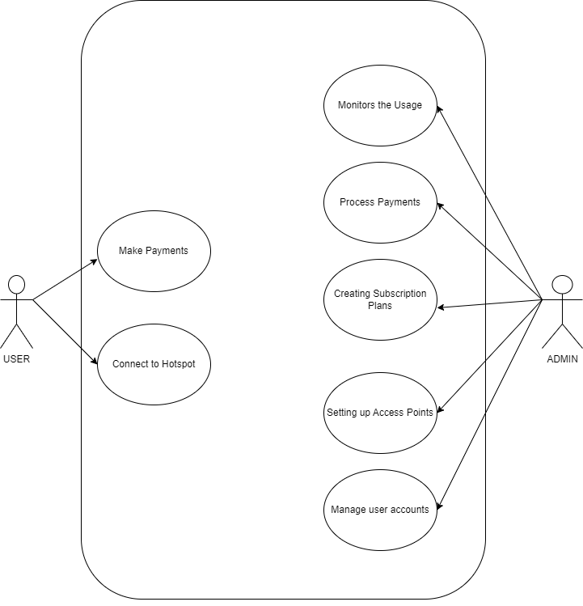
Figure 4.1: Use case Diagram

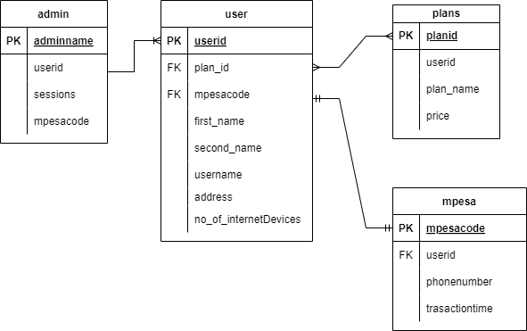
Figure 4.2: Entity Relationship Diagram

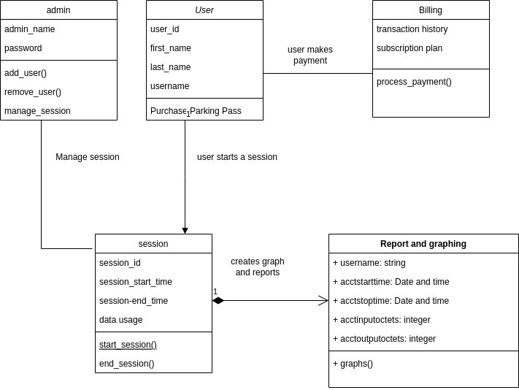
Figure 4.3: class diagram
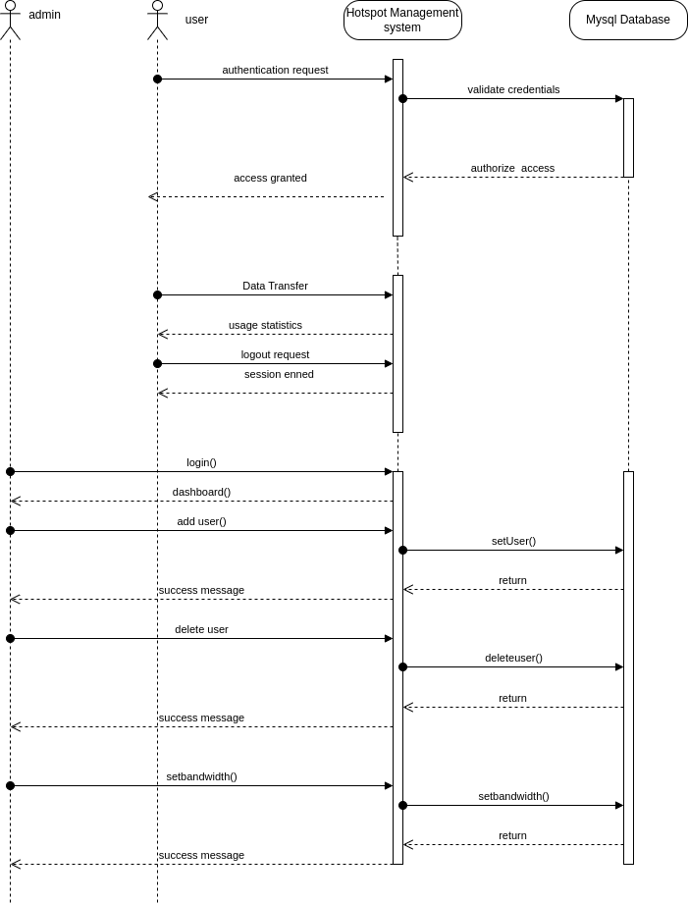
Figure 4.4: sequence diagram

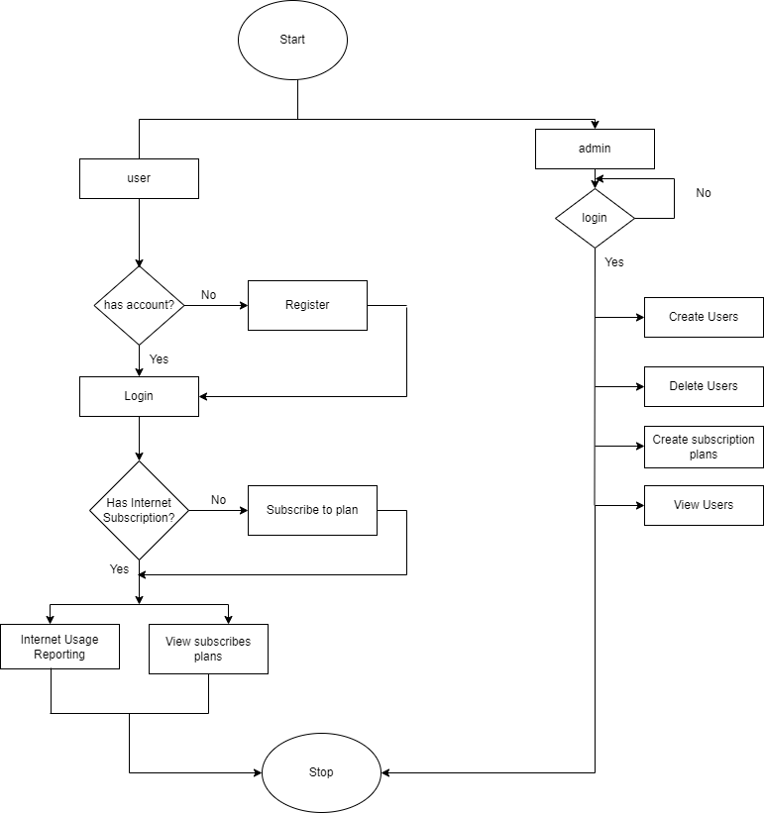
Figure 4.5: flow chart

CHAPTER 5: SYSTEM TESTING AND IMPLEMENTATION

Introduction
This chapter illustrates the functional system modules that have been implemented and the
Validation and the verification methods used to test their efficiency.

Testing

Unit Testing
Unit testing is whereby the individual components of the system are tested. Hotspot Management System components were each tested to ensure they produce the expected results. The system was tested on chrome and Mozilla Firefox we browsers and worked flawless for all the functions. For the M-pesa payment a dummy transaction was made to test if the software was sending STK push to users for payment. The graphing part of the system was tested to determine if it provides real-time bandwidth analytics. To test if the system could register users a user was allowed to register his details and the admin confirmed if the details were stored on the database also the admin tested to see if he also can be able to add users to the system.

Dashboard
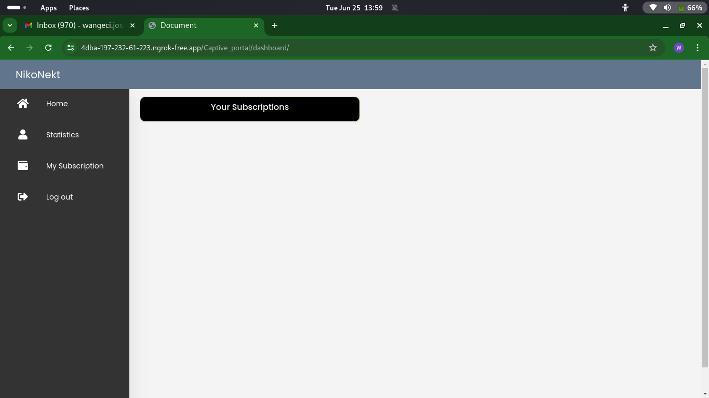
Figure 5.1: Dashboard

User registration
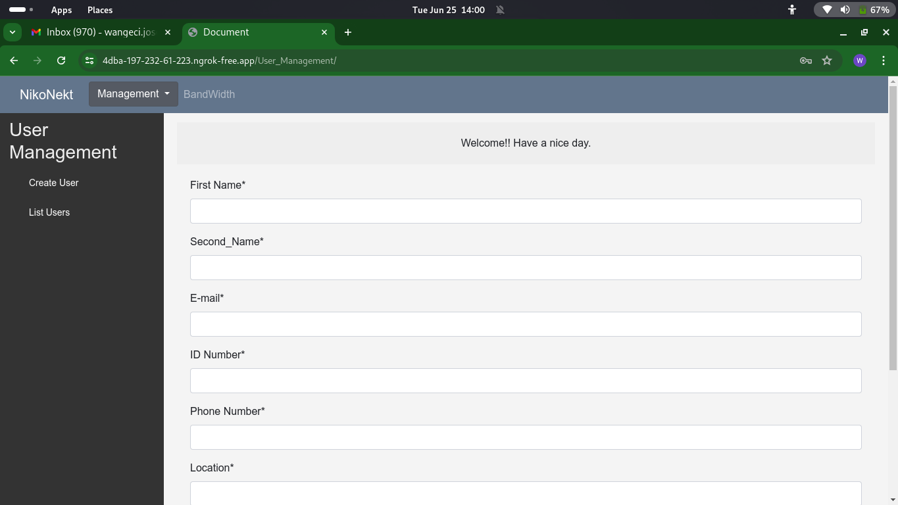
Figure 5.2: user registration

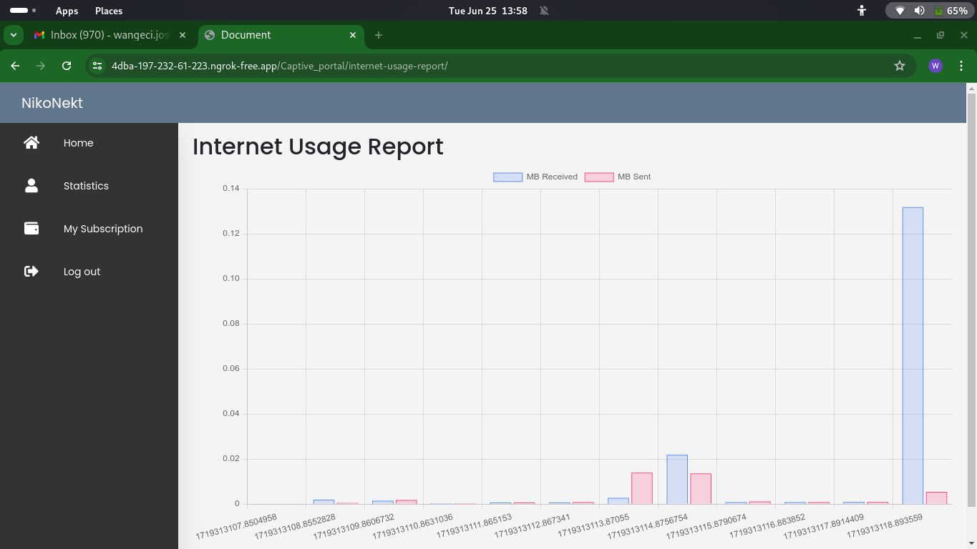
Internet usage reporting
Figure 5.3: Internet usage reporting

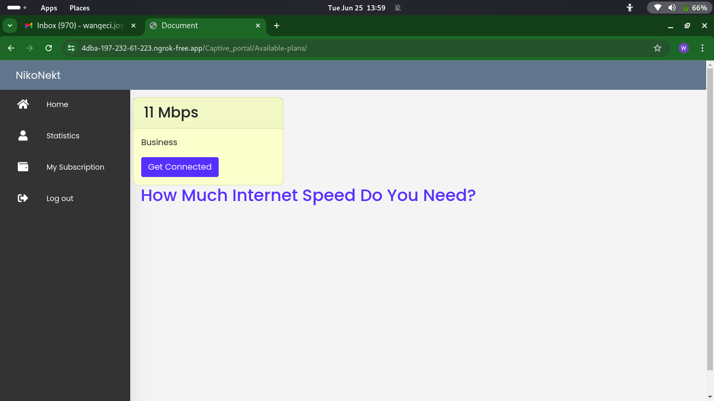
Bandwidth calculator
Figure 5.4: Bandwdth Calculator

Integration Testing
Integration testing is the process of evaluating how individual components or modules of a system work together to ensure they interact correctly and meet the system's functional and interface requirements. It ensures that integrated parts function seamlessly as a whole. Various interconnected components of the Hotspot Management System, such as billing systems, user authentication, User registration, and Internet usage reporting were tested. Given the complexity of system, integration testing verifies that these modules interact properly and function cohesively as a system.

Implementation
Implementation involves the actual development and deployment of the system based on the
Design specifications outlined in the previous phases. It encompasses various tasks, including
Coding, configuration, integration of modules, and deployment of the application. Throughout the implementation process, I adhered to best practices, coding standards, and project management methodologies to ensure the successful execution of the project. The software must be configured to work with existing network infrastructure and hardware, including setting up routers, switches, and integrating with external systems like payment gateways and DNS servers.
Integration is a crucial part of the implementation phase, involving the combination of individual components into a cohesive system. This ensures that modules like user authentication, bandwidth management, and billing systems work together seamlessly.

CHAPTER 6: CONCLUSION AND RECOMMENDATION

Conclusion
In conclusion, the development of the ISP software marks a significant step forward in improving the efficiency and quality of service for Internet Service Providers. Through the integration of key features such as automated billing, real-time network monitoring, customer management, and reporting capabilities, this software is poised to streamline operations and enhance customer satisfaction. The comprehensive approach taken in its design ensures scalability, security, and flexibility, allowing it to meet the evolving needs of ISPs. As technology advances, this software can be continuously updated to incorporate new features, ensuring long-term relevance and performance improvements. Overall, the successful completion of this project demonstrates its potential to provide a reliable solution for the industry while offering users a more seamless experience.

Limitations
During the development of the system, several limitations were encountered that impacted the project’s progress. One of the primary challenges was the limited availability of powerful routers capable of supporting all the advanced features required by the software, such as dynamic bandwidth allocation, real-time traffic monitoring, and enhanced security protocols. This restricted our ability to fully test and implement certain functionalities. Additionally, financial constraints played a significant role, as budget limitations restricted access to necessary infrastructure such as hosting of the system to production, development tools, and testing equipment. As a result, we had to prioritize core features over more advanced capabilities, delaying some hardware upgrades. Legal and regulatory limitations also posed challenges, particularly in ensuring compliance with various data privacy laws and security standards across different regions. Navigating these complex frameworks required additional development time and resources, affecting project timelines. Despite these constraints, the core functionality of the software was successfully developed, though addressing these limitations in future iterations will be crucial for further enhancement and scalability.

Recommendations
To enhance the Hotspot Management System, several key improvements can be made to boost user experience, functionality, and security. First, the user interface (UI) and user experience (UX) should be optimized with simplified navigation and a mobile-responsive design. Offering a dark mode option can further improve accessibility. The user portal should also include diagnostic tools for troubleshooting basic issues without needing to contact customer service.
To improve support and communication, a live chat feature, ticketing system, and an extensive FAQ section can be included, along with a community forum for users to share insights and solutions. Performance-wise, embedding a speed test tool within the app and providing real-time outage notifications will help users stay informed about their connection. A service availability checker will also be beneficial for potential customers. Security should be a top priority, with the addition of multi-factor authentication, password management tools, and parental controls for content restriction. Ensuring that user data is encrypted, while offering privacy settings, will foster trust and protect sensitive information.
Custom notifications, such as push alerts for billing reminders, data usage warnings, and service updates, will keep users informed. Meanwhile, user feedback forms and detailed analytics on usage patterns can help both users and the ISP make informed decisions. Together, these improvements will create a more efficient, user-friendly, and secure experience, improving satisfaction and streamlining customer support.
.

References
Al-Saqqa, S. (2020). Agile System Development: Methodologies and Trends.
Damayanti, N. R., & Sobri, M. (2020). Wireless LAN NetworkAuthentication Captive Portal.
Kao, Y., Liu, J., Ke, Y., Tsai, S., & Lin, Y. (2020). Dual-stack network management through one-time authentication mechanism. IEEE Access, 8, 34706-34716. https://doi.org/10.1109/access.2020.2974659
Khairuddin1, A., & Bahari, A. (2023). Wi-Fi Login Authentications System Using MikroTik.
(2023, September 25). Mawingu. https://mawingu.co/
Onno, S., Gelloz, R., Heen, O., & Neumann, C. (2012). User-based authentication for wireless home networks. 2012 IEEE Second International Conference on Consumer Electronics - Berlin (ICCE-Berlin). https://doi.org/10.1109/icce-berlin.2012.6336530
Parmanasari, A. E., Hidayah, I., & Bustoni, I. A. (2015). Forecasting Model for Hotspot Bandwidth Management at Department of Electrical Engineering and Information Technology UGM.
Rahman, A., & Haviluddin. (2016). Implementation of Bandwidth Management Authentication.
Saliu, A. M. (2013). Internet authentication and billing (Hotspot) system using MikroTik router operating system. International Journal of Wireless Communications and Mobile Computing, 1(1), 51. https://doi.org/10.11648/j.wcmc.20130101.18
Soewito, B., & Hirzi. (2014). Building secure wireless access point based on certificate authentication and firewall captive Portal. EPJ Web of Conferences, 68, 00029. https://doi.org/10.1051/epjconf/20146800029
WiFiLAN – Centralized RADIUS & Billing Solution. (n.d.). Wifisoft - Enterprise WiFi, WiFi Hotspots and IOT Solutions. https://www.wifi-soft.com/download/docs/WiFiLAN-Overview.pdf

APPENDICES

APPENDIX A: Budget.

Hardware | Software
Laptop | Windows 10
Hard disk | Visual Studio Code
Android Mobile Device | Draw.io
Printing Materials | Database
Electricity | Django

Items | Cost
Laptop | 20000
Internet connectivity | 4000
Printing materials | 1500
Electricity | 500
Total | Ksh 26,000

APPENDIX B: Project schedule.
Duration
 | September | October | November | December | January | February |  | March | April-June
Proposal presentation
Gathering of
Requirements
and necessary
information
Development
Prototype
Progress
presentation
Finish on the
development
Presentation
of the final
work

